# Provide implementation

Please provide implementation for the following class diagram

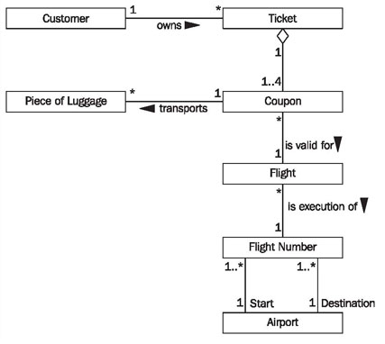

This app should provide console interface for the following functionality:

* Retrieve customers
* Retrieve list of tickets by customer ID and Coupons it contains
* Retrieve Coupon details and Flights under it if exist and Flight number details and Airport information

## Customers

* Name
* Id (unique)

## Ticket

* Id

## Coupon

* Id

## Luggage

* Weight
* Id

## Flight

* Id

## Flight Number

* Departure
* Description
* Airline

## Airport

* Name
* ID